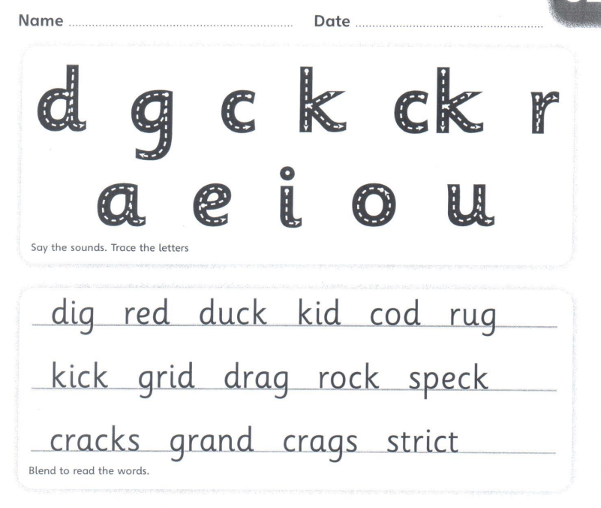

Copy the sentence out
A grand red duck kicks a rock on a rug.
____________________________________________________________________
Now can you put cracks into a sentence.
____________________________________________________________________

